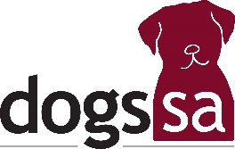
Agenda

Retrieving & Field Trials Advisory Panel Special Meeting to be held on Wednesday 5th November 2025 commencing at 7.00 pm in the Marsula Room at David Roche Park

1. Opening and welcome

2. Present

3. Apologies

4. Minutes: RAFT Special Meeting of Wednesday 6th November 2024

5. Business Arising:

6. Chairperson’s Report & Retrieving Report

7. Field Report
None held

8. Financial Report
Receipts and Payments statement for 2025

9. RAFT Panel Membership 2025-26 (4 - 7 required, Chair elected from those.)

10. Trophy Presentation:
Dogs SA Top Retrieving Gundog
and
Nancy Edwards Memorial Trophy for the highest scoring South Australian competitor in the 2025 National Championship Retrieving Trial for Gundogs.

11. General Business:
a. Retrieving Trial Dates 2026 as provided by Dogs SA
b. SA State Championship 2026
c.

12. Any Other Business: None. (Agenda items to Executive Officer no later than 1st September)

13. Close

